**Pizza Sales SQL Queries**

**KPI’s**

**Pizza Sales DataSet Loading**

select * from pizza_sales

1. **Daily Trend of total Orders AS Total Revenue:**

select sum(total_price) AS Total_Revenue from pizza_sales

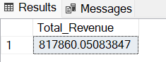

**2.Daily Trend of total Orders As Avg_order_value:**

select sum(total_price)/count(distinct order_id) as Avg_order_value from pizza_sales

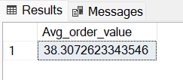

**3. Total Pizzas Sold:**

select sum(quantity) as Total_Pizza_sold from pizza_sales

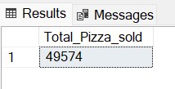

**4.Total Orders:**

select count(distinct order_id) as Total_order_Place from pizza_sales

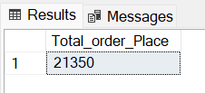

**5. Average Pizzas Per Order:**

select CAST(CAST(sum(quantity) AS DECIMAL(10,2))/

CAST(count(distinct order_id) AS DECIMAL(10,2)) AS DECIMAL(10,2))as Avg_Pizzas_per_order from pizza_sales

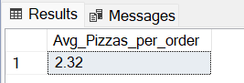

**A.Percentage By Pizza Category :**

SELECT pizza_category, sum(total_price) * 100 / (SELECT sum(total_price) from pizza_sales) as PCT_Sales

from pizza_sales

group by pizza_category

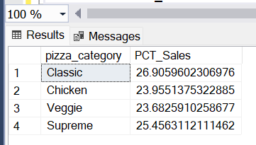

**B.Percentage By Pizzas Size:**

SELECT pizza_size, CAST(SUM(total_price) AS DECIMAL(10,2)) as total_revenue,

CAST(SUM(total_price) * 100 / (SELECT SUM(total_price) from pizza_sales) AS DECIMAL(10,2)) AS PCT

FROM pizza_sales

GROUP BY pizza_size

ORDER BY pizza_size

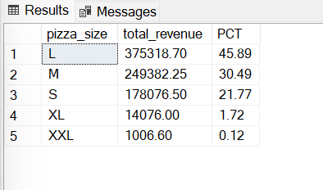

**C. Total Pizzas Sold by Pizza Category:**

SELECT pizza_category, SUM(quantity) as Total_Quantity_Sold

FROM pizza_sales

WHERE MONTH(order_date) = 2

GROUP BY pizza_category

ORDER BY Total_Quantity_Sold DESC

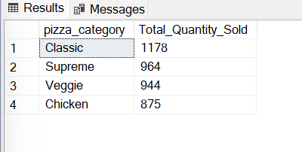

**D.Total orders By Orders Day:**

select DATENAME(DW, order_date) as order_Day, COUNT(DISTINCT order_id) as total_orders from pizza_sales

Group by DATENAME(DW, order_date)

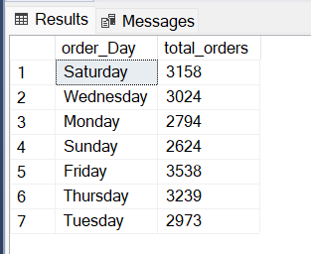

**E.Total Orders By Month:**

select DATENAME(MONTH, order_date) as MONTH_NAME, COUNT(DISTINCT order_id) as total_orders from pizza_sales

Group by DATENAME(MONTH, order_date)

ORDER BY total_orders DESC

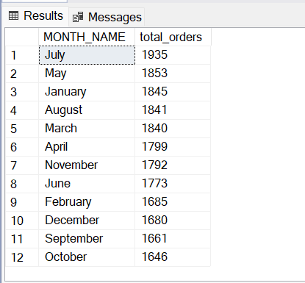

**F.Pizzas Name by Total Price:**

SELECT pizza_name, SUM(total_price) AS Total_Revenue

FROM pizza_sales

GROUP BY pizza_name

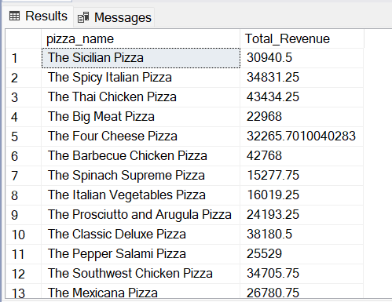

**Best/ Worst Sellers**

**1.Top 5 pizzas Revenue:**

SELECT Top 5 pizza_name, SUM(total_price) AS Total_Revenue

FROM pizza_sales

GROUP BY pizza_name

ORDER BY Total_Revenue DESC

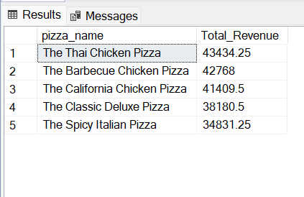

**2.Bottom 5 pizzas Revenue:**

SELECT Top 5 pizza_name, SUM(total_price) AS Total_Revenue

FROM pizza_sales

GROUP BY pizza_name

ORDER BY Total_Revenue ASC

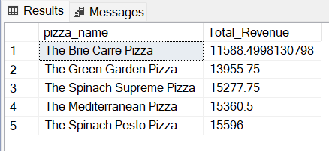

**3. Top 5 Pizzas by Quantity:**

SELECT Top 5 pizza_name, SUM(quantity) AS Total_Pizza_Sold

FROM pizza_sales

GROUP BY pizza_name

ORDER BY Total_Pizza_Sold DESC

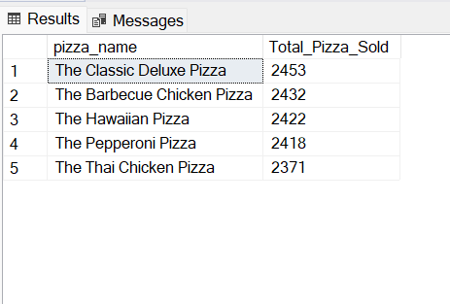

**4. Bottom 5 Pizzas by Quantity:**

SELECT TOP 5 pizza_name, SUM(quantity) AS Total_Pizza_Sold

FROM pizza_sales

GROUP BY pizza_name

ORDER BY Total_Pizza_Sold ASC

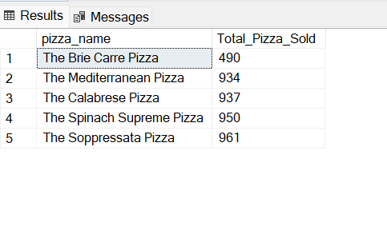

**5.Top 5 Pizzas by Total Orders:**

SELECT Top 5 pizza_name, COUNT(DISTINCT order_id) AS Total_Orders

FROM pizza_sales

GROUP BY pizza_name

ORDER BY Total_Orders DESC

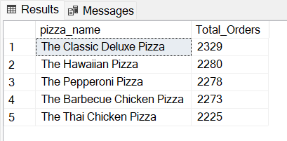

**6. Bottom 5 Pizzas by Total Orders:**

SELECT Top 5 pizza_name, COUNT(DISTINCT order_id) AS Total_Orders

FROM pizza_sales

GROUP BY pizza_name

ORDER BY Total_Orders ASC

